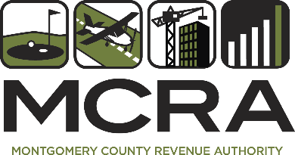

MCRA Board of Directors

October 21, 2025 at 8:30 a.m.
18810 Woodfield Road, Gaithersburg, MD 20879

Open Session Agenda

- Approval of the minutes of September 30, 2025

- Public Comments (Each speaker will receive 3 minutes) Total time will be 9 minutes. Speakers must sign up in advance by emailing gjamison@mcra-md.com.

- Airpark Update: North end development and Airpark Community Advisory Committee (ACAC) response

- Resolution to name Keith Miller as Resident Agent.

Proposed motion: Motion to authorize Keith Miller to serve as Resident Agent for the Montgomery County Revenue Authority.

- Closed Session: The MCRA Board will enter into a closed session to consult with counsel to obtain legal advice, pursuant to Maryland Code, General Provisions Article §3-305(b)(7); and to discuss the appointment, employment, assignment, promotion, discipline, demotion, compensation, removal, resignation, or performance evaluation of an appointee, employee, or official over whom it has jurisdiction, pursuant to Maryland Code, General Provisions Article §3-305(b)(1)(i). Topics include consultation with counsel to obtain legal advice and personnel matters concerning one or more specific appointees, employees, or officials.

ADA Reasonable Accommodations: Sign language interpreter services and other types of reasonable accommodations will be provided upon request, preferably 5 business days or with as much advance notice as possible. Please email gjamison@mcra-md.com. In all situations, a good faith effort (up until the time of the event) will be made to provide accommodations.

For more information about using sign language interpreters, contact Anil Saini, ADA Compliance Program Manager, at 240-777-5362 or Anil.Saini@montgomerycountymd.gov.

